**System Analysis and Modelling Document**

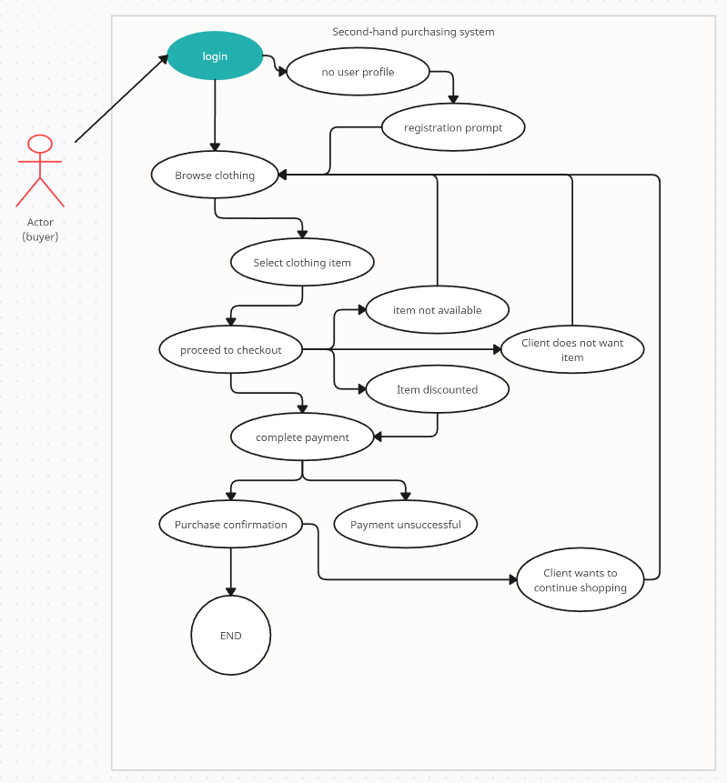

|  |  |  |  |  |
| --- | --- | --- | --- | --- |
| **USE CASE** | | 1 | Client purchase of a product | |
| **Description of Goal in Context** | | The goal is the purchase of a second-hand clothing item through the platform. | | |
| **Preconditions** | | Purchasable products are available on the platform.  The account verification system is integrated.  The ad posting system has relevant and available listings.  There is a functioning verification system for user authenticity.  The shopping cart functionality is operational.  A secure payment system is integrated.  A delivery system is in place for successful order fulfilment. | | |
| **Post Conditions, Success End Condition** | | The user has successfully purchased the selected item, and the transaction is reflected in their user profile. The system loops back, allowing the user to make more purchases. | | |
| **DESCRIPTION** | | The goal of this use case is to facilitate the seamless purchase of a second-hand clothing item by a client through the platform. The process involves the client logging into the system, browsing available second-hand clothing items, selecting an item for purchase, adding it to the shopping cart, proceeding to checkout, completing the payment securely, and receiving confirmation of the purchase. Successful completion of this process results in the client's user profile being updated to reflect the transaction, allowing for the possibility of additional purchases. | | |
| **Main Flow** | | | | |
| **Step** | **Action** | | | **Alternate** |
| 1.1 | Client login | | | 1 |
| 1.2 | Client browse for clothing | | |  |
| 1.3 | Client selects clothing item | | |  |
| 1.4 | Client goes to checkout | | | 2 |
| 1.5 | Payment completion | | | 3 |
| 1.6 | Purchase confirmation | | |  |
|  | | | | |
| **EXCEPTIONS or ERROR Flow Description** | | | | |
| **Step** | **Branching Action**  < Exception number m of Use Case n> | | | **Alternate** |
| 1.1.1 | Client doesn’t have a profile  Prompt the user to create an account | | |  |
| 1.4.1 | Selected item is not available  Notifies client and returns to browsing state | | |  |
| 1.5.1 | Payment wasn’t successful  Alert the client with the error, offer solutions | | |  |
|  |  | | |  |
|  | | | | |
| **ALTERNATIVE or VARIATION Flow Description** | | | | |
| **Step** | **Branching Action** | | | **Alternate** |
| 1.4.1 | Item is discounted  Apply discount and notify the client | | |  |
| 1.4.2 | Client decides to not buy the item  Remove item from shopping cart and return to browsing state | | |  |
| 1.6.1 | Client wants to continue shopping  Return to browsing state | | |  |

**Use Case 2: User Account Registration**

Description of Goal in Context:

The goal is to allow a new user to register an account on the platform, providing necessary information for personalized services.

**Preconditions:**

1. User has access to the registration page.

2. Email address and password requirements are met.

3. Captcha verification is successfully completed.

**Post Conditions, Success End Condition:**

The user account is created, and the system redirects the user to their personalized dashboard.

**Main Flow:**

1. The user navigates to the registration page.

2. The user enters their email address and password.

3. The system verifies the email format and password strength.

4. The user completes Captcha verification.

5. The system creates the user account.

6. The system redirects the user to their personalized dashboard.

**Exceptions/Error Flow**

1. If the email address is already registered.

- The system prompts the user to use a different email address.

2. If the password is weak.

- The system notifies the user of the password requirements and prompts them to choose a stronger password.

3. If Captcha verification fails.

- The system provides an option to refresh the Captcha or choose an alternative verification method.

**Use Case 3: Product Listing by Seller**

**Description of Goal in Context:**

The goal is to enable a seller to list a product for sale on the platform.

**Preconditions:**

1. Seller has a registered account.

2. Seller is logged into the system.

3. Seller has product details and images ready for listing.

**Post Conditions, Success End Condition:**

The product is successfully listed on the platform for potential buyers.

**Main Flow:**

1. The seller logs into the system.

2. The seller navigates to the product listing page.

3. The seller enters product details (title, description, price, etc.).

4. The seller uploads images of the product.

5. The system validates the information and images.

6. The system lists the product on the platform.

**Exceptions/Error Flow**

1. If the seller is not logged in.

- The system prompts the seller to log in before proceeding.

2. If essential product details are missing.

- The system highlights the missing information and prompts the seller to complete the required fields.

3. If image validation fails.

- The system notifies the seller of image requirements and prompts them to upload valid images.

**Use Case 4: Product Search and Filter**

**Description of Goal in Context:**

The goal is to allow users to search for specific products and apply filters for a refined search experience.

**Preconditions:**

1. User is logged into the system.

2. The platform has a database of available products.

**Post Conditions, Success End Condition:**

The user sees a list of products matching the search criteria.

**Main Flow:**

1. The user enters a search query in the search bar.

2. The system displays relevant results.

3. The user applies filters (e.g., price range, brand).

4. The system updates the displayed products based on the applied filters.

**Exceptions/Error Flow**

1. If the search query yields no results.

- The system suggests alternative search terms or encourages the user to broaden their search criteria.

2. If there is a system error preventing filter application.

- The system informs the user of the issue and encourages them to try again.

3. If the user attempts to apply incompatible filters.

- The system notifies the user that certain filters cannot be applied simultaneously and guides them to choose appropriate options.